CS349 ASSIGNMENT 2 Rashi Singh
Network Protocol Analysis Using Wireshark 170101052

Q1 : PROTOCOLS USED IN DIFF LAYERS
Network Layer :
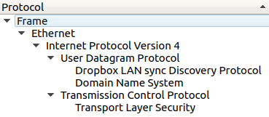Figure 1: Protocol Hierarchy used by DropBox
IPv4 : Internet Protocol Version 4 :
IPv4 is a network-layer protocol used in packet-switched layer networks, such as Ethernet. It provides a logical connection between network devices by providing identification for each device and routing data among them over the underlying network. IP uses best effort delivery, i.e. it does not guarantee that packets would be delivered to the destined host, but it will do its best to reach the destination. Internet Protocol version 4 uses
32-bit logical address.

IPv4 - Packet Structure :
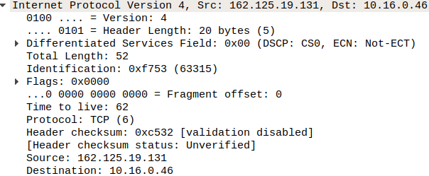Figure 3: WireShark IPv4 layer packet details
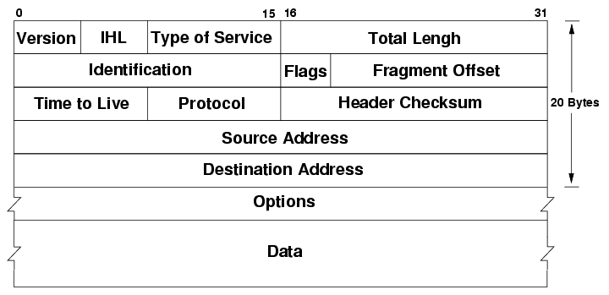Figure 2: IPv4 Header Structure

VERSION - (4 bit) Version of the Internet Protocol used
HEADER LENGTH - (4 bit) Length of the IP header in 32 bit increments.
**Min length of IP header is 20 bytes, so with 32 bit increments, min value of IHL is 5.
**Max value of IHL is 15 so with 32 bit increments, max length of IP header is 60 bytes
TYPE OF SERVICE - Provides an indication of the abstract parameters of the quality of service desired.
TOTAL LENGTH - (16 bit) Length of the datagram (in bytes), including internet header and data.
IDENTIFICATION - An identifying value assigned by the sender to help assemble the fragments of a datagram
Flags - (3 bit) Various Control Flags
FRAGMENT OFFSET - (13 bit) Indicating where in the datagram this fragment belongs.
TIME TO LIVE - (8 bit) The max time the datagram is allowed to remain in the internet system.
PROTOCOL - Next level protocol used in the data portion of the internet datagram.
HEADER CHECKSUM - A checksum on the header only.
SOURCE/DEST ADDRESS - (32 bit) Addr of the source/destination respectively
Transport Layer :
TCP : Transport Control Protocol :
TCP is a connection oriented protocol which offers end-to-end packet delivery. TCP ensures reliability by sequencing bytes with a forwarding acknowledgement number that indicates to the destination, the next byte
the source expect to receive.It retransmits the bytes not acknowledged with in specified time period.
Dropbox mainly used TCP to send application data mainly due its reliability feature
TCP - Packet Structure :
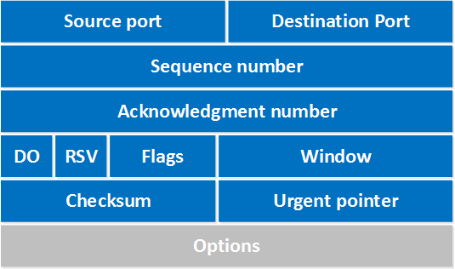Figure 4: TCP header structure
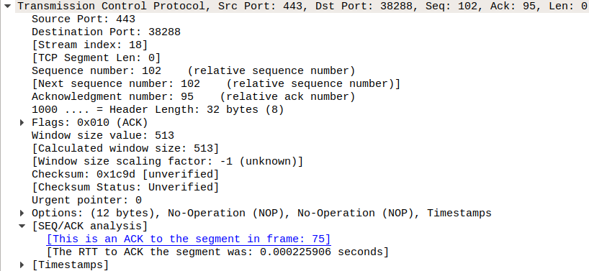Figure 5: WireShark TCP packet details

SOURCE/DEST PORT : (16 bit) Fields to identify the end points of the connection.
SEQUENCE # : (32 bit) Number assigned to the first byte of data in the current message
ACKNOWLEDGEMENT # : (32 bit) Value of the next sequence # that the sender of the segment is expecting to receive
DATA OFFSET : Specifies how many 32-bit words are contained in the TCP header.
RESERVED : (6 bit) Must be zero. This is for future use.
FLAGS : (6 bit) URG, ACK, PSH, RST, SYN, FIN
WINDOW : (16 bit) Specifies the size of the sender's receive window
CHECKSUM : (16 bit) Indicates whether the header was damaged in transit.
URGENT : pointer (16 bit) Points to the first urgent data byte in the packet.
OPTIONS : (variable length) Specifies various TCP options.
DATA : (variable length) Contains upper-layer information.
UDP : User Datagram Protocol :
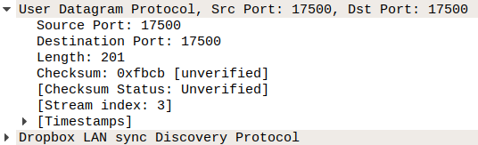Figure 6: WireShark UDP packet details
- UDP is connectionless and unreliable protocol. It doesn’t require making a connection with the host to exchange data. Since UDP is unreliable protocol, there is no mechanism for ensuring that data sent is received.
- UDP is used by the application that typically transmit small amount of data at one time. UDP datagram consists of the following : Src/Dest Port, Length,Checksum (same as TCP header)

DB-LSP-DISC : DropBox LAN Sync Discovery Protocol :
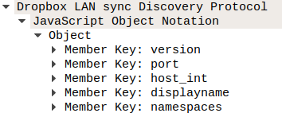Figure 7: WireShark DB-LSP-DISC packet details

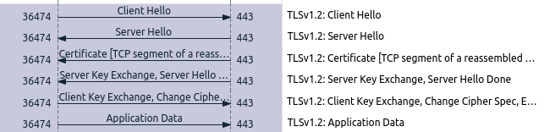Figure 8: TLS packet exchange
B/w Application, Transport Layer :
TLSv1.2 : Transport Layer Security
It is a cryptographic protocol, developed
from the generalized version of SSL(Secure
Socket Layer)(now deprecated). It
provides 3 essential services to the
applications running above it:

**TLS requires a reliable transport. Hence, it uses TCP Verification of validity of identity : AUTHENTICATION a)
Detection of msg tampering, forgery : DATA INTEGRITY b)
A mechanism to obfuscate what is sent from one host to another : ENCRYPTION c)
PACKETS for TLSv1.2
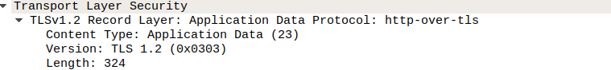Figure 9: Common parameters in TLS packets
The common parameters present in diff. kinds of TLS packets are :
a) VERSION : 16 byte version
b) LENGTH : 16 byte record length,
formatted in network order
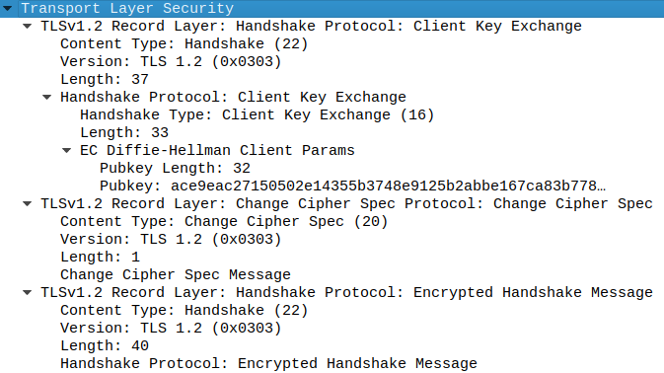
c) CONTENT TYPE : This signifies the types of TLS packets that are recognized. As in Figure 8: TLS packet exchange, some of the common types are :
1) handshake
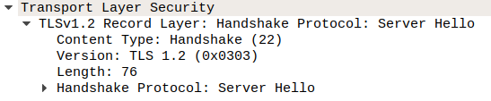
2) application_data
3) change_cipher_spec
4) alert, heartbeat etc...

